28.54: a)
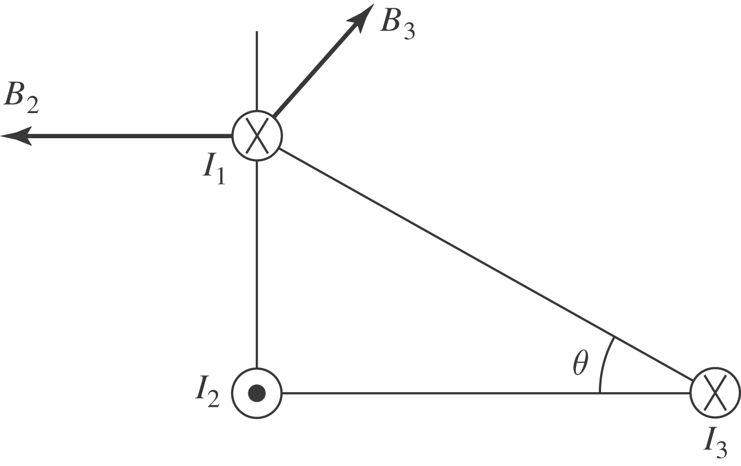

b) 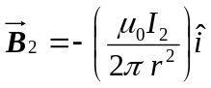 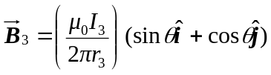
And so
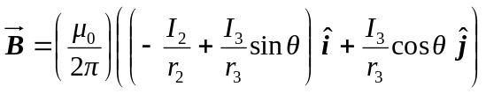
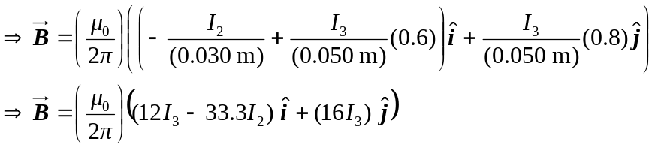
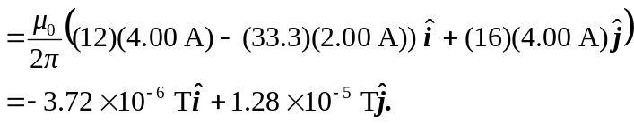
c) 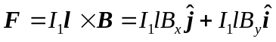
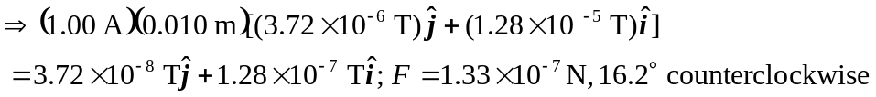
from +x-axis.

